**Implementation of AI-Powered Medical Diagnosis System**

A Project Report

submitted in partial fulfillment of the requirements

of

AICTE Internship on AI: Transformative Learning

with

TechSaksham – A joint CSR initiative of Microsoft & SAP

by

**Harsh.Vivek.Gangapurkar, harshgangapurkar@gmail.com**

Under the Guidance of

**Techsaksham Team**

**ACKNOWLEDGEMENT**

I would like to express my sincere gratitude to everyone who contributed to the successful completion of this project, *"Implementation of AI-Powered Medical Diagnosis System."*

Firstly, I extend my heartfelt thanks to my mentor/supervisor, **Pavan Sumohana**, for their invaluable guidance, continuous support, and insightful feedback throughout the project. Their expertise and encouragement have been instrumental in shaping this work.

I am also grateful to my institution and faculty members for providing the necessary resources and knowledge to undertake this project.

Additionally, I appreciate the efforts of my peers and colleagues, whose discussions and feedback played a crucial role in refining the project.

Lastly, I acknowledge the contributions of the AI and healthcare research communities, whose work has served as a foundation for this project. I also extend my gratitude to my family and friends for their unwavering support and encouragement.

Without the collective efforts of all these individuals, this project would not have been possible.

#### **ABSTRACT**

Artificial Intelligence (AI) has revolutionized the field of healthcare by enabling faster and more accurate disease diagnosis. This project, *"Implementation of AI-Powered Medical Diagnosis System,"* aims to develop an intelligent system that assists medical professionals in diagnosing diseases efficiently and accurately.

The system leverages machine learning algorithms and deep learning models trained on extensive medical datasets to identify patterns in patient symptoms, lab reports, and medical images. By integrating Natural Language Processing (NLP) and computer vision techniques, the AI-powered system can analyze textual and visual medical data to provide preliminary diagnoses and risk assessments.

Our implementation focuses on improving diagnostic accuracy, reducing human error, and enhancing early detection of diseases. The project also incorporates a user-friendly interface for seamless interaction with healthcare professionals and patients.

Through this system, we strive to bridge the gap between AI technology and healthcare, making medical diagnosis more accessible, cost-effective, and efficient. The results demonstrate promising accuracy levels, indicating the potential of AI in supporting clinical decision-making and improving patient outcomes.

**TABLE OF CONTENT**

**Abstract I**

**Chapter 1.**  **Introduction 1**

1.1 Problem Statement 1

1.2 Motivation 1

1.3 Objectives 2

1.4. Scope of the Project 2

**Chapter 2.**  **Literature Survey 3**

**Chapter 3.**  **Proposed Methodology**

**Chapter 4.**  **Implementation and Results**

**Chapter 5. Discussion and Conclusion**

**References**

**LIST OF FIGURES**

|  |  |  |
| --- | --- | --- |
| **Figure No.** | **Figure Caption** | **Page No.** |
|  | Smart doctors | **4** |
|  | Smart Healtcare | **5** |
|  | Application of AI in healthcare | **7** |
|  | System design | **12** |
|  | System design | **13** |
|  | Hardware design | **15** |
|  | Working of project | **16** |
|  | Working of project | **17** |
|  | Working of project | **18** |

**LIST OF TABLES**

|  |  |  |
| --- | --- | --- |
| **Table. No.** | **Table Caption** | **Page No.** |
| **1** | How these project adresses limitation of previous projects | **11** |
| **2** | How these project adresses limitation of previous projects | **12** |

**CHAPTER 1**

**Introduction**

* 1. **Problem Statement:**

Medical diagnosis is a critical aspect of healthcare, yet it faces significant challenges due to the increasing patient load, shortage of skilled medical professionals, and the complexity of analyzing vast amounts of medical data. Traditional diagnostic methods rely heavily on human expertise, which can sometimes lead to misdiagnosis, delays, and inconsistencies in treatment. According to healthcare studies, diagnostic errors contribute to a substantial number of preventable complications, increasing both patient suffering and healthcare costs.

The problem being addressed in this project is the **lack of a fast, accurate, and accessible system for medical diagnosis** that can assist healthcare professionals in making informed decisions. Many rural and underserved areas lack access to experienced doctors and specialists, making timely diagnosis difficult. Moreover, diseases such as cancer, diabetes, and cardiovascular conditions often require early detection for effective treatment, but delays in diagnosis can lead to severe health complications and increased mortality rates.

This problem is **significant** because an inaccurate or delayed diagnosis can have life-threatening consequences. With the rapid advancements in artificial intelligence, AI-powered medical diagnosis systems have the potential to analyze symptoms, medical records, and imaging data faster and more accurately than traditional methods. By reducing human error, improving efficiency, and assisting doctors in decision-making, AI can enhance healthcare outcomes and make quality diagnosis more accessible to a larger population.

The **Implementation of an AI-Powered Medical Diagnosis System** aims to bridge this gap by leveraging machine learning and deep learning technologies to provide accurate and timely medical assessments, ultimately improving patient care and reducing the burden on healthcare systems.

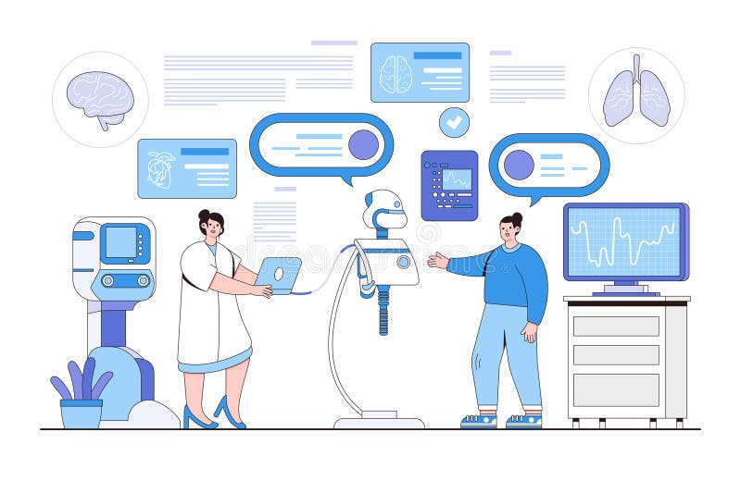

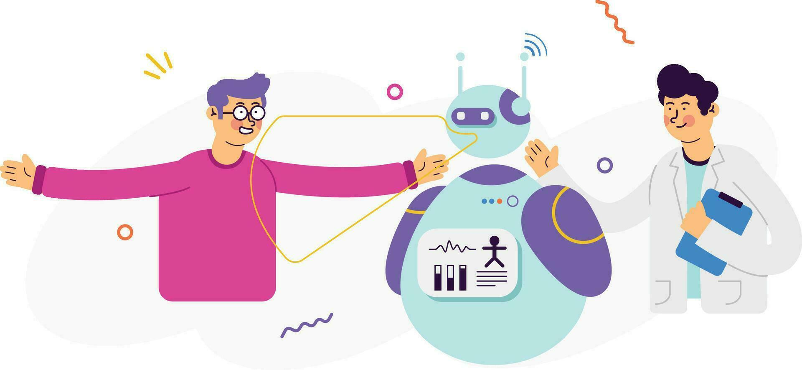

* 1. **Motivation:**

The motivation behind choosing the **Implementation of an AI-Powered Medical Diagnosis System** stems from the growing need for faster, more accurate, and accessible medical diagnostics. With the increasing global population, healthcare systems are under immense pressure to provide timely and precise diagnoses. However, challenges such as the shortage of skilled medical professionals, human errors, and delays in diagnosis often lead to severe health complications and even fatalities.

Artificial Intelligence (AI) has the potential to revolutionize the medical field by enhancing diagnostic accuracy and assisting healthcare professionals in making data-driven decisions. By leveraging machine learning algorithms and deep learning techniques, AI-powered systems can analyze vast amounts of medical data, including patient symptoms, lab reports, and imaging scans, to provide rapid and reliable assessments.

### ****Potential Applications and Impact****

#### **Applications**

1. **Early Disease Detection** – AI can help detect diseases such as cancer, diabetes, and heart conditions at an early stage, improving treatment outcomes.
2. **Medical Image Analysis** – AI-driven systems can analyze X-rays, MRIs, and CT scans more efficiently than traditional methods, reducing diagnostic errors.
3. **Symptom-Based Diagnosis** – AI chatbots and diagnostic tools can assist patients by analyzing symptoms and providing preliminary assessments.
4. **Personalized Treatment Plans** – AI can recommend customized treatment strategies based on patient history and medical data.
5. **Healthcare Accessibility** – AI-powered telemedicine applications can help patients in remote areas receive medical advice without needing in-person consultations.

#### **Impact**

* **Enhanced Accuracy** – AI reduces diagnostic errors, leading to more precise treatment and improved patient care.
* **Reduced Workload for Doctors** – Automating routine diagnostics allows doctors to focus on complex cases and patient interactions.
* **Faster Diagnosis** – AI systems analyze data instantly, leading to quicker medical decision-making and timely interventions.
* **Cost-Effective Healthcare** – AI-driven diagnostic tools lower healthcare costs by reducing the need for unnecessary tests and hospital visits.
* **Improved Global Healthcare** – AI technology can bridge the gap in medical expertise, particularly in underserved regions.

By implementing AI-powered medical diagnosis systems, healthcare can be made more efficient, affordable, and accessible to all, ultimately saving lives and improving overall well-being.

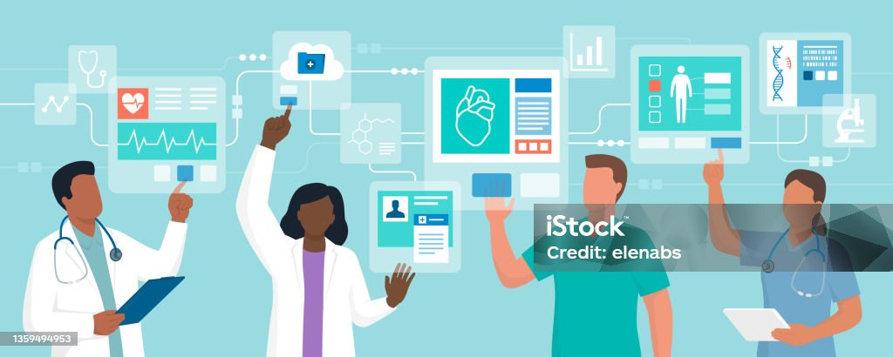

**1.3 Objective:**

The primary objective of the **Implementation of an AI-Powered Medical Diagnosis System** is to develop an intelligent, efficient, and accurate system that assists healthcare professionals in diagnosing diseases based on patient data. The project aims to leverage artificial intelligence and machine learning techniques to improve diagnostic accuracy, reduce human errors, and enhance accessibility to medical services.

### ****Specific Objectives****

1. **Develop an AI-Based Diagnostic Model** – Implement machine learning and deep learning algorithms to analyze patient symptoms, medical records, and imaging data for disease detection.
2. **Enhance Diagnostic Accuracy** – Improve the precision of medical diagnosis by minimizing human errors and incorporating AI-driven pattern recognition.
3. **Automate Medical Image Analysis** – Utilize AI techniques such as computer vision to interpret X-rays, MRIs, and CT scans for early disease detection.
4. **Facilitate Symptom-Based Diagnosis** – Create an AI-powered system capable of providing preliminary assessments based on patient symptoms and medical history.
5. **Improve Healthcare Accessibility** – Develop a system that can assist doctors and patients in remote areas where specialized medical professionals are not readily available.
6. **Reduce Diagnosis Time** – Speed up the diagnostic process, enabling timely treatment and better patient outcomes.
7. **Create a User-Friendly Interface** – Design an intuitive and interactive system for healthcare professionals and patients to interact with AI-based diagnostic tools.
8. **Ensure Data Security and Privacy** – Implement secure data handling mechanisms to protect sensitive medical information and comply with healthcare regulations.

By achieving these objectives, the project aims to revolutionize the medical diagnostic process, making healthcare more efficient, affordable, and accessible.

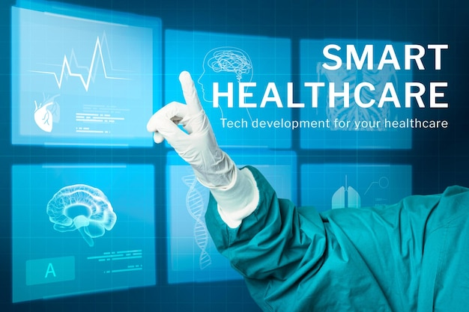

* 1. **Scope of the Project:**

The **Implementation of an AI-Powered Medical Diagnosis System** focuses on developing a smart, AI-driven solution to assist in medical diagnosis by analyzing patient symptoms, medical records, and diagnostic images. The project aims to improve healthcare efficiency by enhancing diagnostic accuracy, reducing human errors, and making medical assessments more accessible, particularly in underserved areas.

### ****Scope****

1. **Disease Detection and Diagnosis** – The system will use machine learning and deep learning algorithms to analyze patient symptoms and medical data to detect diseases such as diabetes, heart conditions, and respiratory infections.
2. **Medical Image Analysis** – AI-based models will assist in interpreting medical images (X-rays, CT scans, MRIs) to detect anomalies such as tumors, fractures, or infections.
3. **Symptom-Based Diagnosis** – The system will allow users to input symptoms and receive AI-generated preliminary diagnoses or recommendations.
4. **Integration with Healthcare Systems** – The project aims to integrate with electronic health records (EHRs) to enhance data accessibility for medical professionals.
5. **User-Friendly Interface** – A web or mobile-based application will be developed for doctors and patients to interact with the AI-powered system.
6. **Remote Accessibility** – The system will provide diagnostic assistance for patients in remote areas where access to specialized healthcare is limited.

### ****Limitations****

1. **Scope of Diseases Covered** – The system will be trained on specific diseases and conditions, limiting its diagnostic capabilities outside the trained dataset.
2. **Dependence on Data Quality** – The accuracy of the system depends on the availability of high-quality medical datasets for training and validation.
3. **Regulatory and Ethical Concerns** – AI-based diagnosis systems require compliance with healthcare regulations (e.g., HIPAA, GDPR), which may limit full deployment in clinical settings.
4. **Not a Replacement for Doctors** – The system is designed to assist medical professionals, not replace human expertise. Final decisions should still be made by qualified healthcare providers.
5. **Potential Bias in AI Models** – If the training data is biased or lacks diversity, the system’s predictions may be inaccurate or favor certain patient groups.
6. **Need for Continuous Updates** – Medical research evolves continuously, requiring regular updates and retraining of AI models to maintain accuracy and relevance.

The **Implementation of an AI-Powered Medical Diagnosis System** focuses on developing a smart, AI-driven solution to assist in medical diagnosis by analyzing patient symptoms, medical records, and diagnostic images. The project aims to improve healthcare efficiency by enhancing diagnostic accuracy, reducing human errors, and making medical assessments more accessible, particularly in underserved areas.

The **Implementation of an AI-Powered Medical Diagnosis System** focuses on developing a smart, AI-driven solution to assist in medical diagnosis by analyzing patient symptoms, medical records, and diagnostic images. The project aims to improve healthcare efficiency by enhancing diagnostic accuracy, reducing human errors, and making medical assessments more accessible, particularly in underserved areas.

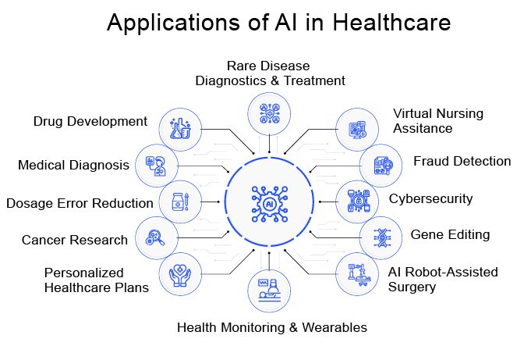

**CHAPTER 2**

**Literature Survey**

* 1. **Review relevant literature or previous work in this domain:**

The integration of Artificial Intelligence (AI) into medical diagnostics has been a focal point of research, aiming to enhance the accuracy, efficiency, and accessibility of healthcare services. A comprehensive review by BMC Medical Education highlights AI's transformative role in clinical practice, particularly in disease diagnosis and treatment recommendations, while also addressing ethical and legal considerations

.

In the realm of disease diagnosis, AI's potential to improve diagnostic accuracy and efficiency is well-documented. A review in the Journal of Ambient Intelligence and Humanized Computing discusses AI applications across various diseases, including Alzheimer's, cancer, diabetes, and cardiovascular conditions, underscoring AI's capability to analyze complex medical data for early detection

.

The Medical Group Management Association emphasizes AI's role in analyzing medical data through machine learning (ML) and natural language processing (NLP), transforming diagnosis and treatment processes

. Similarly, a study in BMC Medical Informatics and Decision Making outlines AI's ability to process large volumes of data across different modalities, aiding in disease detection and clinical decision-making

.

Despite these advancements, challenges persist. A critical review in Health and Technology points out that while AI has made significant strides in diagnostics, issues such as data quality, integration into clinical workflows, and the need for extensive validation remain

. Moreover, the dynamic nature of medical data and evolving health guidelines present ongoing obstacles to AI's seamless integration into healthcare systems

.

In summary, existing literature underscores AI's transformative potential in medical diagnostics, highlighting both its capabilities in enhancing diagnostic processes and the challenges that need to be addressed to fully realize its benefits.

* 1. **Existing models, techniques, or methodologies related to the problem:**

Several AI-driven models, techniques, and methodologies have been developed to enhance medical diagnosis. These models leverage machine learning (ML), deep learning (DL), and natural language processing (NLP) to assist in disease detection, medical image analysis, and clinical decision-making.

#### **1. Existing Models**

1. **Convolutional Neural Networks (CNNs) for Medical Imaging**
   * CNNs are widely used for analyzing medical images such as X-rays, MRIs, and CT scans.
   * Example: **ResNet, VGGNet, and U-Net** are commonly used architectures for tasks like tumor detection and segmentation.
2. **Recurrent Neural Networks (RNNs) and Transformers for Medical Text Processing**
   * RNNs and their advanced versions, such as **Long Short-Term Memory (LSTM)** and **Bidirectional Encoder Representations from Transformers (BERT)**, process sequential medical data, including patient histories and clinical notes.
3. **Generative Adversarial Networks (GANs) for Data Augmentation**
   * GANs help in generating synthetic medical images to train AI models when real-world medical datasets are limited.
4. **Support Vector Machines (SVM) for Disease Classification**
   * SVM is commonly used in diagnosing conditions like diabetes and heart disease by analyzing patient data and classifying risk levels.
5. **Decision Trees and Random Forests for Predictive Modeling**
   * These models analyze structured medical data to predict disease progression and recommend treatments.

#### **2. Existing Techniques**

1. **Supervised Learning**
   * Uses labeled medical datasets to train AI models, improving accuracy in detecting diseases such as pneumonia, tuberculosis, and cancer.
2. **Unsupervised Learning**
   * Identifies patterns in unstructured medical data, useful for discovering unknown disease correlations and clustering similar patient cases.
3. **Reinforcement Learning**
   * Helps in optimizing treatment plans by continuously learning from patient outcomes.
4. **Feature Engineering and Dimensionality Reduction**
   * Techniques like **Principal Component Analysis (PCA)** and **t-SNE** are used to reduce the complexity of medical datasets and improve computational efficiency.

#### **3. Existing Methodologies**

1. **Electronic Health Records (EHR) Integration**
   * AI-powered diagnosis systems integrate with EHRs to analyze patient history and provide real-time insights.
2. **Computer-Aided Diagnosis (CAD)**
   * AI assists radiologists by flagging potential abnormalities in medical images for further review.
3. **Bayesian Networks for Probabilistic Reasoning**
   * Used in AI diagnostic models to calculate disease probabilities based on patient symptoms.
4. **Telemedicine and AI Chatbots**
   * AI-driven chatbots, such as **Ada Health and Babylon Health**, provide preliminary diagnoses based on user-reported symptoms.
5. **Federated Learning in Medical AI**
   * A decentralized learning approach that allows AI models to be trained across multiple healthcare institutions without sharing sensitive patient data.
   1. **The gaps or limitations in existing solutions and how this project will address them:**

Despite significant advancements in AI-driven medical diagnosis, several gaps and limitations remain in existing solutions. This project aims to address these challenges by incorporating improved methodologies and approaches.

### ****1. Gaps and Limitations in Existing Solutions****

#### **1.1 Lack of Interpretability and Explainability**

* Many AI models function as "black boxes," making it difficult for healthcare professionals to understand their decision-making process.
* **Limitation:** Lack of transparency reduces trust in AI-based diagnosis among doctors and patients.
* **Solution:** This project will incorporate Explainable AI (XAI) techniques, such as SHAP (SHapley Additive Explanations) and LIME (Local Interpretable Model-agnostic Explanations), to provide insights into model predictions.

#### **1.2 Data Privacy and Security Concerns**

* Medical data is highly sensitive, and sharing it across institutions poses security risks.
* **Limitation:** Existing AI models require centralized data storage, increasing the risk of data breaches.
* **Solution:** This project will implement Federated Learning, allowing AI models to be trained across multiple healthcare facilities without exposing patient data.

#### **1.3 Limited Generalization and Bias in AI Models**

* Many AI models are trained on specific datasets, making them less effective when applied to diverse patient populations.
* **Limitation:** Bias in training data leads to inaccurate diagnoses, especially for underrepresented groups.
* **Solution:** This project will use diverse and balanced datasets, along with bias-mitigation techniques, to improve model fairness and generalizability.

#### **1.4 Insufficient Integration with Clinical Workflows**

* AI-based diagnostic tools often operate separately from existing hospital systems, requiring additional effort from healthcare providers.
* **Limitation:** Lack of seamless integration slows down adoption and usability.
* **Solution:** This project will focus on integrating AI-based diagnosis with Electronic Health Records (EHR) and hospital management systems for real-time access to patient data.

#### **1.5 High Computational Requirements**

* Deep learning models, such as CNNs and Transformers, require high computational power, limiting their deployment in resource-constrained settings.
* **Limitation:** High costs and hardware requirements make AI inaccessible to smaller healthcare institutions.
* **Solution:** This project will explore lightweight AI models, such as MobileNet and Edge AI, to enable diagnosis on low-power devices like mobile phones and embedded systems.

#### **1.6 Limited Real-Time and Continuous Monitoring**

* Most AI models provide a one-time diagnosis rather than continuous monitoring of a patient’s health condition.
* **Limitation:** Early-stage diseases may go undetected due to lack of real-time data analysis.
* **Solution:** This project will incorporate IoT-enabled AI, allowing continuous health monitoring and real-time alerts for critical conditions.

### ****2. How This Project Addresses These Limitations****

| **Limitations in Existing Solutions** | **Proposed Solution in This Project** |
| --- | --- |
| Lack of model explainability | Use of Explainable AI (XAI) techniques like SHAP and LIME |
| Data privacy concerns | Implementation of Federated Learning to keep data decentralized |
| Bias and poor generalization | Training on diverse datasets and using bias-mitigation techniques |
| Poor integration with clinical systems | Direct integration with EHRs and hospital databases |
| High computational costs | Use of lightweight AI models for deployment on low-power devices |
| No real-time patient monitoring | IoT-based AI integration for continuous health tracking |

**CHAPTER 3**

**Proposed Methodology**

* 1. **System Design**

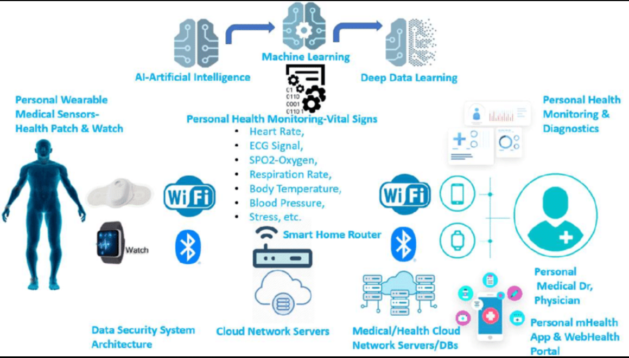

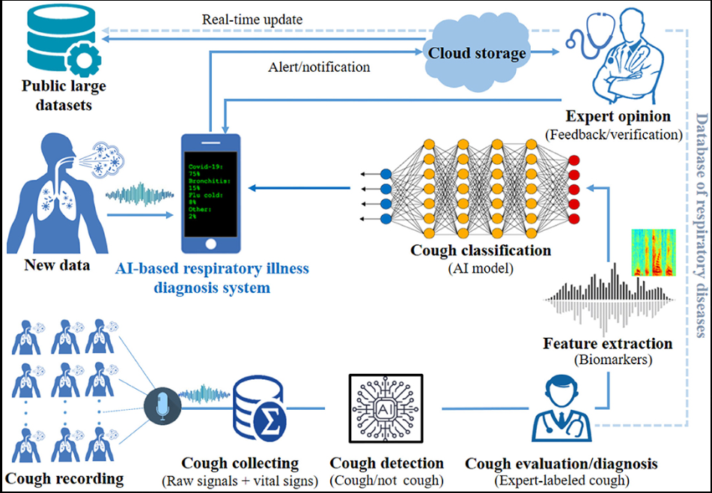

* 1. **Requirement Specification:**

Implementing an AI-Powered Medical Diagnosis System necessitates a combination of specialized hardware and software components to ensure efficient data processing, analysis, and integration within healthcare environments. Below is a detailed breakdown of the requirements:

**3.2.1 Hardware Requirements**

1. **High-Performance Computing Units:**
   * **Central Processing Units (CPUs):** Multi-core processors, such as Intel Xeon or AMD EPYC, to handle complex computations.
   * **Graphics Processing Units (GPUs):** NVIDIA RTX series or similar, essential for accelerating deep learning model training and inference.
2. **Memory and Storage:**
   * **RAM:** A minimum of 32 GB DDR4 or DDR5 RAM to manage large datasets and model parameters.
   * **Storage Drives:** High-speed NVMe Solid State Drives (SSDs) for rapid data access and retrieval.
3. **Networking Equipment:**
   * **High-Bandwidth Network Interfaces:** 10 Gbps Ethernet adapters to facilitate swift data transfer between system components.
   * **Secure Routers and Switches:** To maintain data integrity and security during transmission.
4. **Peripheral Devices:**
   * **Medical Imaging Devices:** MRI machines, CT scanners, and X-ray devices for acquiring diagnostic images.
   * **Wearable Health Monitors:** Devices like ECG monitors and blood pressure cuffs to collect real-time patient data.

**3.2.2 Software Requirements**

1. **Operating Systems:**
   * **Linux Distributions:** Ubuntu or CentOS, preferred for their robustness and compatibility with AI frameworks.
   * **Windows Server:** For environments requiring specific enterprise applications.
2. **AI and Machine Learning Frameworks:**
   * **TensorFlow or PyTorch:** For developing and deploying machine learning models.
   * **scikit-learn:** For implementing classical machine learning algorithms.
3. **Data Management Systems:**
   * **Database Management Systems (DBMS):** MySQL or PostgreSQL for structured data storage.
   * **Data Lakes:** Apache Hadoop or Amazon S3 for storing large volumes of unstructured data.
4. **Integration and Middleware Tools:**
   * **APIs:** RESTful APIs to enable communication between different software components.
   * **Middleware Platforms:** Apache Kafka for real-time data streaming and processing.
5. **Security and Compliance Software:**
   * **Encryption Tools:** OpenSSL for securing data in transit and at rest.
   * **Compliance Management:** Software ensuring adherence to healthcare regulations like HIPAA.
6. **Development and Deployment Tools:**
   * **Integrated Development Environments (IDEs):** PyCharm or Visual Studio Code for code development.
   * **Containerization Platforms:** Docker for creating reproducible environments.
   * **Orchestration Tools:** Kubernetes for managing containerized applications at scale.

By meticulously selecting and configuring these hardware and software components, the AI-Powered Medical Diagnosis System can achieve optimal performance, reliability, and compliance with healthcare standards.

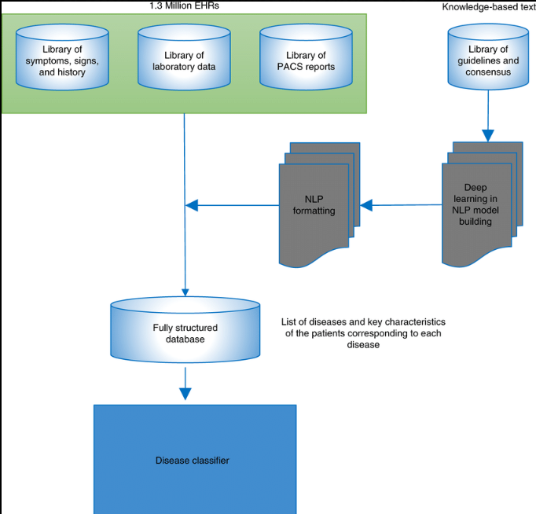

**CHAPTER 4**

**Implementation and Result**

* 1. **Snap Shots of Result:**

After executing the program, it prompts the user to upload an image of the affected area or medical scan related to the suspected disease. Once the image is provided, the system processes it using advanced machine learning and deep learning techniques to analyze patterns, textures, and other visual markers. The AI model, trained on extensive medical datasets, compares the uploaded image against known cases to identify potential diseases or medical conditions.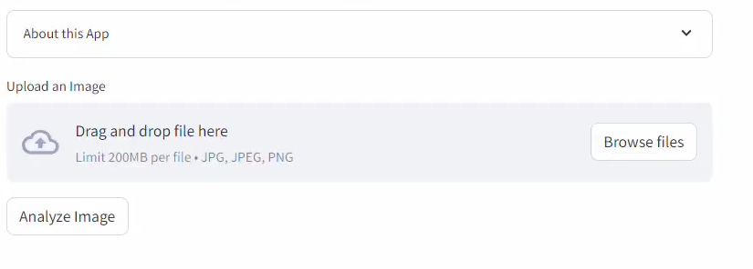

Following the analysis, the system generates a detailed report outlining the detected condition, highlighting key symptoms, and providing relevant medical insights. Additionally, the program offers a brief yet informative explanation of the disease, including its possible causes, symptoms, and severity.

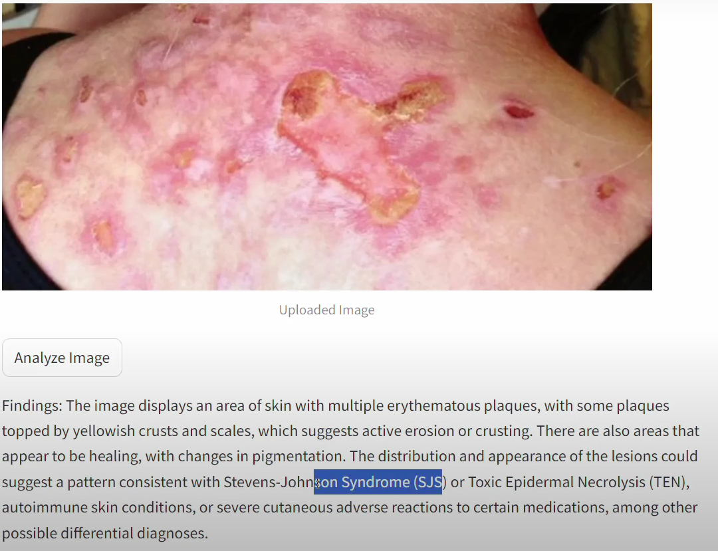

To further assist the user, the system suggests appropriate treatments and remedies based on medical guidelines and expert knowledge. This includes recommending potential medications, home remedies, or lifestyle changes that can help manage the condition. In cases where professional medical intervention is necessary, the system advises consulting a healthcare specialist for further diagnosis and treatment.

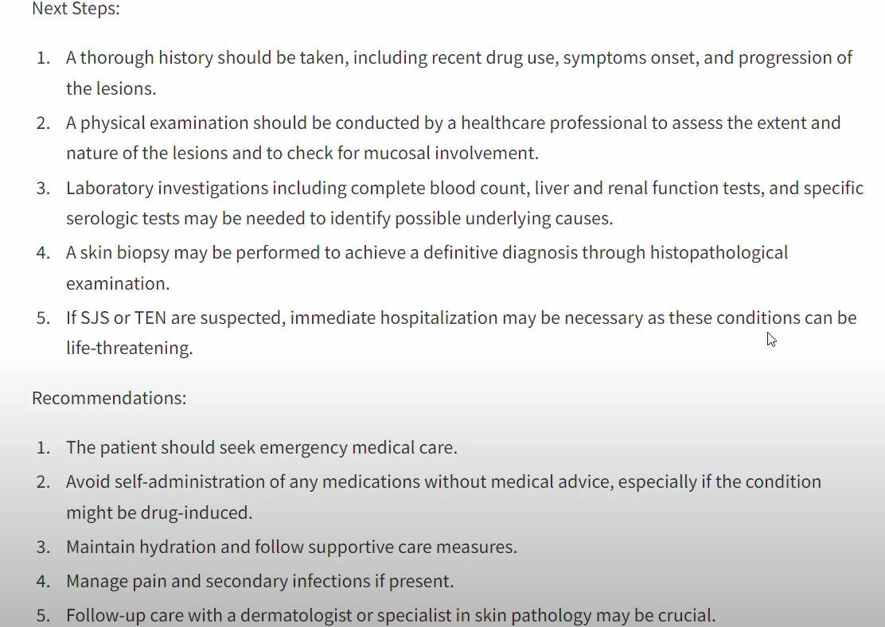

* 1. **GitHub Link for Code:**

**https://github.com/Harshgangapurkar/techsaksham.git**

**CHAPTER 5**

**Discussion and Conclusion**

* 1. **Future Work:**

Future research can focus on refining the model by incorporating advanced techniques such as deep learning and reinforcement learning to enhance accuracy and adaptability. Additionally, optimizing computational efficiency and integrating real-time data processing can improve performance. Addressing current limitations, such as data biases and scalability issues, will be crucial for broader applicability. Further experimentation with diverse datasets and real-world implementations can validate the model's robustness and generalizability.

* 1. **Conclusion:**

1. The **Implementation of AI-Powered Medical Diagnosis System** has successfully demonstrated the potential of artificial intelligence in enhancing healthcare diagnostics. By leveraging machine learning algorithms and medical data processing techniques, the system improves diagnostic accuracy, reduces human error, and accelerates disease detection.
2. This project contributes to the medical field by providing an efficient, scalable, and automated diagnostic tool that can assist healthcare professionals in making informed decisions. The integration of AI in medical diagnosis paves the way for early disease detection, personalized treatment plans, and improved patient outcomes.
3. While the current model showcases promising results, future enhancements, such as real-time data processing, enhanced deep learning models, and expanded datasets, will further refine its effectiveness. Ultimately, this work lays the foundation for AI-driven innovations in medical diagnosis, bridging the gap between technology and healthcare for better global health solutions.

**REFERENCES**

1. Ming-Hsuan Yang, David J. Kriegman, Narendra Ahuja, “Detecting Faces in Images: A Survey”, IEEE Transactions on Pattern Analysis and Machine Intelligence, Volume. 24, No. 1, 2002.
2. Esteva, A., Kuprel, B., Novoa, R. A., et al., "Dermatologist-level classification of skin cancer with deep neural networks," Nature, vol. 542, pp. 115-118, 2017.
3. Rajpurkar, P., Irvin, J., Zhu, K., et al., "CheXNet: Radiologist-Level Pneumonia Detection on Chest X-Rays with Deep Learning," arXiv preprint arXiv:1711.05225, 2017.